Notched polyhedron
# Source: AI Source: Provided by: [Data Path: Persons Table -> ID Column: 1, Name_En Column: Motasem Essam] -> From: [ChatGPT] on [7/25/2026]
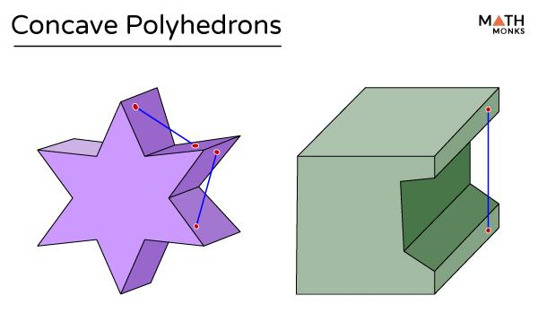
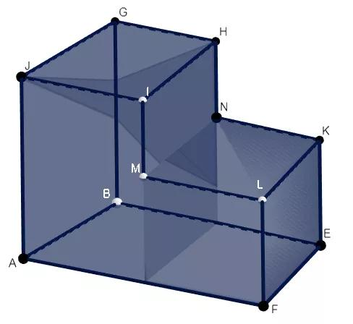
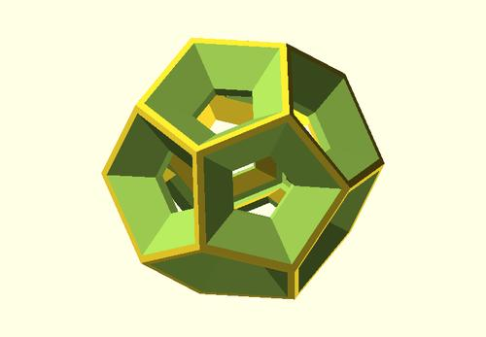

Definition
# Source: AI Source: Provided by: [Data Path: Persons Table -> ID Column: 1, Name_En Column: Motasem Essam] -> From: [ChatGPT] on [7/25/2026]
A notched polyhedron is a concave polyhedron with an inward indentation, or notch, that makes part of its boundary recede into the solid rather than bulge outward.
It can be visualized as a polyhedron with a section cut out of one side. The resulting solid has a concave shape because at least one part of its boundary bends inward in the geometric sense.
A notched polyhedron is not a separate fundamental class of polyhedra with one universal structure. The term describes a shape characterized by one or more notches.

Simple Definition
# Source: AI Source: Provided by: [Data Path: Persons Table -> ID Column: 1, Name_En Column: Motasem Essam] -> From: [ChatGPT] on [7/25/2026]
A notched polyhedron is a three-dimensional solid made of flat polygonal faces that has an inward cut or indentation.
For example, imagine a cube with a smaller rectangular block removed from one side, creating a notch.

Key Characteristics
# Source: AI Source: Provided by: [Data Path: Persons Table -> ID Column: 1, Name_En Column: Motasem Essam] -> From: [ChatGPT] on [7/25/2026]
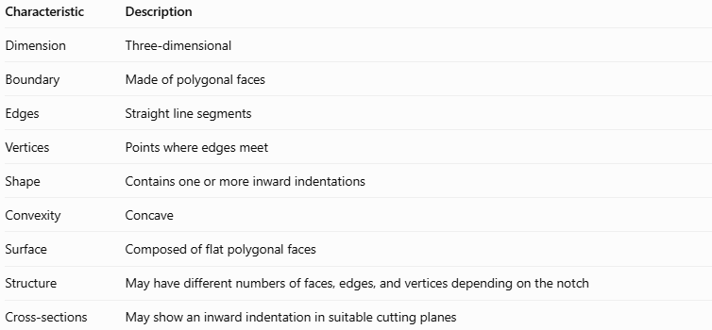
Characteristic | Description
Dimension | Three-dimensional
Boundary | Made of polygonal faces
Edges | Straight line segments
Vertices | Points where edges meet
Shape | Contains one or more inward indentations
Convexity | Concave
Surface | Composed of flat polygonal faces
Structure | May have different numbers of faces, edges, and vertices depending on the notch
Cross-sections | May show an inward indentation in suitable cutting planes

Geometric Representation
# Source: AI Source: Provided by: [Data Path: Persons Table -> ID Column: 1, Name_En Column: Motasem Essam] -> From: [ChatGPT] on [7/25/2026]
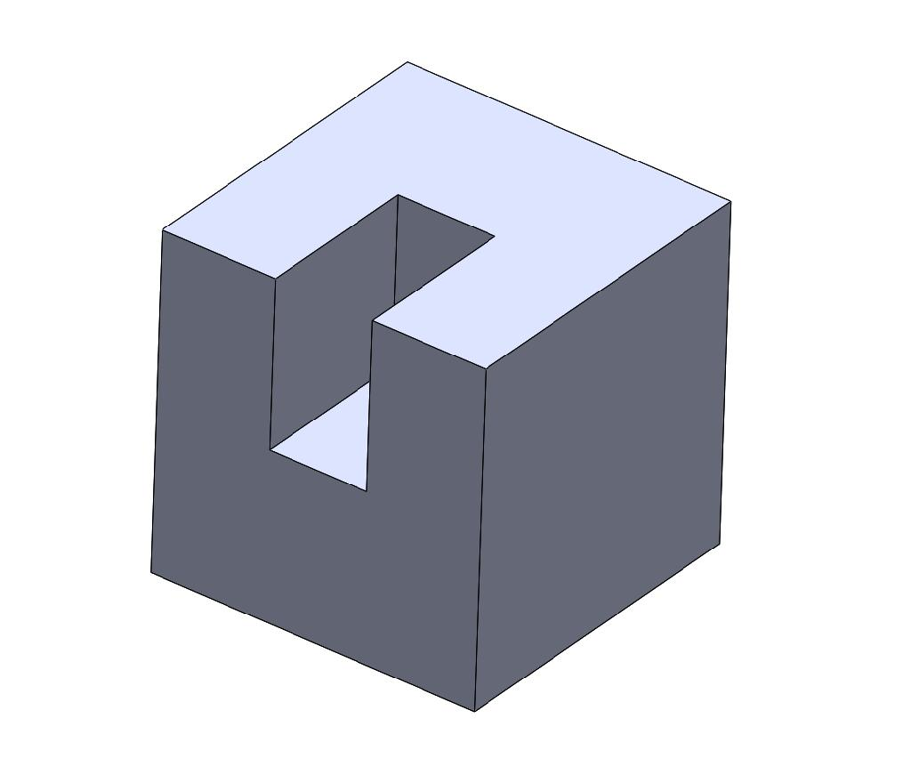
Consider a cube with a rectangular notch cut into one face.
Its main components are:
- Outer faces: The polygonal faces remaining from the original solid.
- Notch faces: The new flat faces exposed by the inward cut.
- Notch edges: Straight edges outlining the indentation.
- Notch vertices: Corners created where the notch faces meet.
- Concave region: The inward portion that prevents the solid from being convex.
The exact number of faces, edges, and vertices depends on the dimensions and shape of the notch.

Mathematical Properties and Formulas
# Source: AI Source: Provided by: [Data Path: Persons Table -> ID Column: 1, Name_En Column: Motasem Essam] -> From: [ChatGPT] on [7/25/2026]
A notched polyhedron does not have one universal formula for its surface area or volume. These quantities depend on its original shape and the dimensions of the removed portion.

Volume
# Source: AI Source: Provided by: [Data Path: Persons Table -> ID Column: 1, Name_En Column: Motasem Essam] -> From: [ChatGPT] on [7/25/2026]
If a notch is created by removing a non-overlapping region from an original solid:
$$V_{\text{remaining}}=V_{\text{original}}-V_{\text{removed}}$$
For a rectangular notch:
$$V_{\text{removed}}=lwh$$
where $l$, $w$, and $h$ are the notch's length, width, and height.

Surface Area
# Source: AI Source: Provided by: [Data Path: Persons Table -> ID Column: 1, Name_En Column: Motasem Essam] -> From: [ChatGPT] on [7/25/2026]
The surface area must account for the faces removed and the new faces exposed by the notch.
$$A_{\text{remaining}}=A_{\text{original}}-A_{\text{removed}}+A_{\text{new}}$$
Here, $A_{\text{removed}}$ is the area of the original exterior surface cut away, while $A_{\text{new}}$ is the total area of the newly exposed faces.

Euler's Formula
# Source: AI Source: Provided by: [Data Path: Persons Table -> ID Column: 1, Name_En Column: Motasem Essam] -> From: [ChatGPT] on [7/25/2026]
For a simple, closed notched polyhedron whose boundary has the topology of a sphere:
$$V_{e}-E+F=2$$
where:
- $V_{e}$ = number of vertices
- $E$ = number of edges
- $F$ = number of faces
Concavity does not invalidate Euler's formula. A simple concave polyhedron can satisfy it just as a convex polyhedron does.

Worked Examples
# Source: AI Source: Provided by: [Data Path: Persons Table -> ID Column: 1, Name_En Column: Motasem Essam] -> From: [ChatGPT] on [7/25/2026]
Example 1: Calculating the Volume
A cube has an edge length of $6\text{ cm}$. A rectangular notch measuring $2\text{ cm}×2\text{ cm}×3\text{ cm}$ is removed.
Step 1 — Calculate the original volume.
$$V_{\text{original}}=6^{3}=216{\text{ cm}}^{3}$$
Step 2 — Calculate the removed volume.
$$V_{\text{removed}}=2×2×3=12{\text{ cm}}^{3}$$
Step 3 — Calculate the remaining volume.
$$V_{\text{remaining}}=216-12=\boxed{204{\text{ cm}}^{3}}$$
Example 2: Calculating the Surface Area
Using the same cube and notch, assume the notch opens through one face and forms a rectangular cavity.
Step 1 — Original surface area.
$$A_{\text{original}}=6\left(6^{2}\right)=216{\text{ cm}}^{2}$$
Step 2 — Account for the surface changes.
- Remove the opening area: $2×2=4{\text{ cm}}^{2}$.
- Add the inner back face: $2×2=4{\text{ cm}}^{2}$.
- Add two side walls: $2\left(2×3\right)=12{\text{ cm}}^{2}$.
- Add the top and bottom walls: $2\left(2×3\right)=12{\text{ cm}}^{2}$.
Step 3 — Calculate the new surface area.
$$A_{\text{remaining}}=216-4+4+12+12$$
$$\boxed{A_{\text{remaining}}=240{\text{ cm}}^{2}}$$

Comparison with Related Concepts
# Source: AI Source: Provided by: [Data Path: Persons Table -> ID Column: 1, Name_En Column: Motasem Essam] -> From: [ChatGPT] on [7/25/2026]
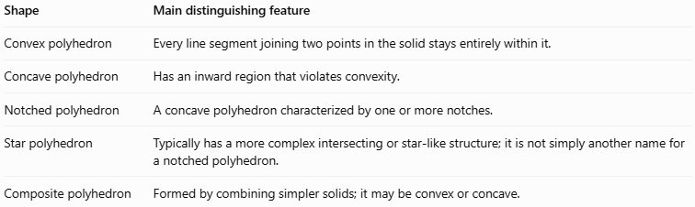
Shape | Main distinguishing feature
Convex polyhedron | Every line segment joining two points in the solid stays entirely within it.
Concave polyhedron | Has an inward region that violates convexity.
Notched polyhedron | A concave polyhedron characterized by one or more notches.
Star polyhedron | Typically has a more complex intersecting or star-like structure; it is not simply another name for a notched polyhedron.
Composite polyhedron | Formed by combining simpler solids; it may be convex or concave.

Constructing Notched Polyhedron in Solid Geometry

Instruments Used
# Source: AI Source: Provided by: [Data Path: Persons Table -> ID Column: 1, Name_En Column: Motasem Essam] -> From: [ChatGPT] on [7/25/2026]
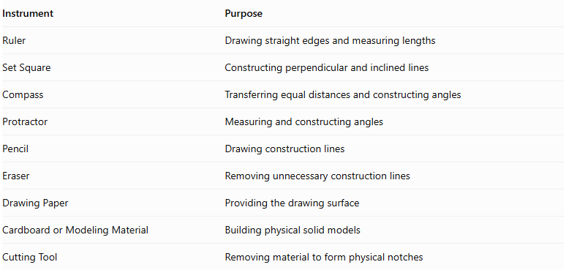
Instrument | Purpose
Ruler | Drawing straight edges and measuring lengths
Set Square | Constructing perpendicular and inclined lines
Compass | Transferring equal distances and constructing angles
Protractor | Measuring and constructing angles
Pencil | Drawing construction lines
Eraser | Removing unnecessary construction lines
Drawing Paper | Providing the drawing surface
Cardboard or Modeling Material | Building physical solid models
Cutting Tool | Removing material to form physical notches

Construction Procedures

A. Original-Solid-Based Construction
# Source: AI Source: Provided by: [Data Path: Persons Table -> ID Column: 1, Name_En Column: Motasem Essam] -> From: [ChatGPT] on [7/25/2026]
This method begins with an existing polyhedron and creates one or more notches.
- Select an original solid, such as a cube, prism, or other polyhedron.
- Draw the original solid using an appropriate pictorial representation.
- Identify the face, edge, or corner where the notch will be created.
- Mark the dimensions and boundaries of the intended notch.
- Draw the polygonal cutting boundaries.
- Construct the inward surfaces of the notch.
- Remove or visually suppress the selected geometric portion.
- Connect the remaining face boundaries.
- Distinguish visible edges from hidden edges.
- Check that the resulting solid has a continuous polygonal surface.

B. Face-Based Construction
# Source: AI Source: Provided by: [Data Path: Persons Table -> ID Column: 1, Name_En Column: Motasem Essam] -> From: [ChatGPT] on [7/25/2026]
- Draw the external polygonal faces of the solid.
- Identify the face where the notch will be located.
- Draw the notch boundary within that face.
- Construct the recessed side faces.
- Connect the recessed faces to the surrounding external faces.
- Complete the remaining surfaces of the polyhedron.

C. Edge-Based Construction
# Source: AI Source: Provided by: [Data Path: Persons Table -> ID Column: 1, Name_En Column: Motasem Essam] -> From: [ChatGPT] on [7/25/2026]
- Draw the original polyhedron.
- Identify the edge region where the notch will be introduced.
- Mark the required cutting boundaries.
- Construct the inward polygonal surfaces.
- Connect the new surfaces to the surrounding faces.
- Complete the visible and hidden edges.

D. Corner-Based Construction
# Source: AI Source: Provided by: [Data Path: Persons Table -> ID Column: 1, Name_En Column: Motasem Essam] -> From: [ChatGPT] on [7/25/2026]
- Draw the original polyhedron.
- Select one or more corners for truncation or removal.
- Mark the boundaries of each removed corner.
- Construct the new polygonal face or faces.
- Connect the new faces to the adjacent original faces.
- Complete the resulting notched geometry.

E. Net-Based Construction
# Source: AI Source: Provided by: [Data Path: Persons Table -> ID Column: 1, Name_En Column: Motasem Essam] -> From: [ChatGPT] on [7/25/2026]
- Determine all external and recessed polygonal faces.
- Draw a connected net containing the required faces.
- Arrange the faces so their shared edges correspond correctly.
- Add tabs if needed for physical assembly.
- Cut out the net.
- Fold along the shared edges.
- Join the corresponding edges to form the notched polyhedron.
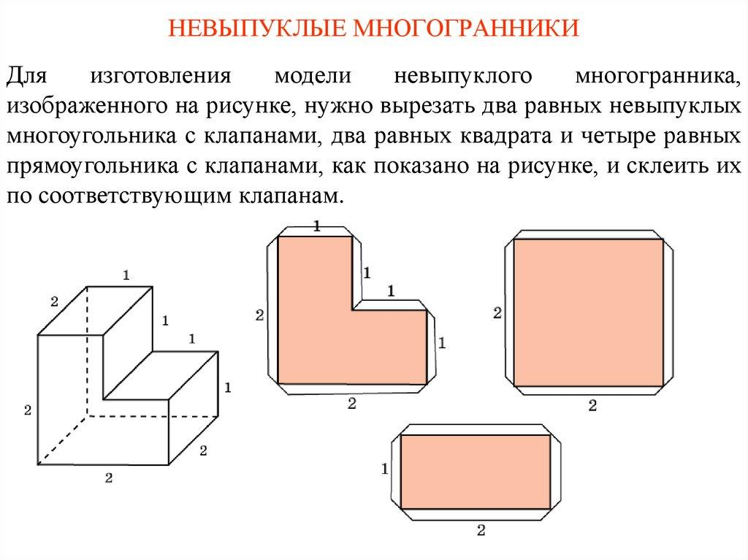

Applications
# Source: AI Source: Provided by: [Data Path: Persons Table -> ID Column: 1, Name_En Column: Motasem Essam] -> From: [ChatGPT] on [7/25/2026]
- Architecture: Modeling buildings with recessed entrances, cutouts, and stepped forms.
- Engineering: Representing components with slots, grooves, and cavities.
- Computer graphics: Modeling concave objects and representing their surfaces.
- Manufacturing: Calculating material removed during machining.
- Geometry education: Demonstrating the difference between convex and concave solids.

Key Points
# Source: AI Source: Provided by: [Data Path: Persons Table -> ID Column: 1, Name_En Column: Motasem Essam] -> From: [ChatGPT] on [7/25/2026]
- A notched polyhedron is a type of concave polyhedron.
- Its boundary consists of flat polygonal faces joined along straight edges.
- A notch creates an inward indentation.
- The number of faces, edges, and vertices depends on the particular construction.
- Its volume can often be calculated by subtracting the removed volume from the original volume.
- Its surface area must include the newly exposed faces.
- Euler's formula $V_{e}-E+F=2$ applies to simple, closed notched polyhedra with sphere-like boundaries.

Conclusion
# Source: AI Source: Provided by: [Data Path: Persons Table -> ID Column: 1, Name_En Column: Motasem Essam] -> From: [ChatGPT] on [7/25/2026]
A notched polyhedron is a useful geometric model for a solid with one or more inward cutouts. Its defining feature is concavity caused by an indentation in an otherwise polygonal boundary. Understanding notched polyhedra helps with classifying three-dimensional shapes, calculating surface area and volume, and modeling objects in engineering and computer graphics.

